

Project: Ubuzima-Link

BSc. in Software Engineering

MAHORO Irakoze Irielle

Supervisor: Yves Mugenga and Neza David Tuyishimire

Date: July 2026

I. DECLARATION

This Proposal Project is my original work, unless stated and all external sources have been referenced or cited in my document. This work has not been presented for award of degree or for any similar purpose in any other university

Signature

Date: 17 July 2026
Name of Student:

MAHORO Irakoze Irielle

II. CERTIFICATION

The undersigned certifies that he has read and hereby recommended for acceptance of African Leadership University a report entitled ………..

Signature……………………… Date………………………….
Prof/Dr./Mrs./Miss/Mr. Name of the Supervisor
Faculty,
Bachelor of Software Engineering,
ALU

III. DEDICATION
First and most important, a huge thank you to God, thank you for giving me strength, wisdom and courage for this huge opportunity. I am eternally grateful to you my Lord.
To my Dad, whose sacrifices made this education possible and whose belief in me never wavered even when mine did.
To every health worker in Rwanda who shows up every day with limited tools and unlimited commitment this was built with you in mind.

IV. ACKNOWLEDGEMENT
This project would not have reached this point without the support of several people I am genuinely grateful for.
To my supervisors, Mr. Neza David Tuyishimire and Mr. Yves Mugenga, thank you for your guidance throughout this process. Your feedback pushed me to think more carefully about both the technical and practical dimensions of this work, and your patience during the difficult phases of development did not go unnoticed.
To the faculty of the Bachelor of Software Engineering at African Leadership University, thank you for three years of education that taught me not just how to write code but how to think about the problems worth solving.
To my classmates and peers who tested the system, gave honest feedback, and stayed up late for the same deadlines,you made this experience worth having.
Finally, to anyone who has ever tried to build something useful under real constraints , I hope this work is a small contribution to the idea that it is possible.

V. Abstract
Referral management between health posts and district hospitals in Rwanda depended heavily on paper based documentation and continuous internet access, both of which were unreliable in many facilities. Paper referral slips were regularly lost or damaged during patient transfers, and when internet connectivity was unavailable, healthcare workers had no way to access or update referral records, disrupting continuity of care.
This project developed Ubuzima-Link, an offline-first referral management system that allowed health post nurses to create patient referrals and generate QR codes without internet access. Referral data was stored locally on the device using IndexedDB and synchronized automatically to the central server when connectivity returned. Patients carried their referral as a QR code on their phone,eliminating the need for printed referral slips. At the receiving hospital, clinicians scanned the QR code to retrieve the referral, tracked patient arrivals, and sent clinical feedback back to the referring health post. An admin portal handled facility and user management, and security measures including two factor authentication, account lockout, and session controls protected patient data throughout.
Testing confirmed that referral creation succeeded under all offline conditions with a 100% local save rate, and all pending referrals synchronized without data loss when connectivity was restored. The system met every functional requirement defined in the project proposal and was successfully deployed at https://ubuzima-link-rhew.vercel.app.
Formal usability testing with healthcare workers remains the primary next step before real world deployment.

VI. Table of Contents

I. DECLARATION 1
II. CERTIFICATION 2
III. DEDICATION 3
V. Abstract 4
VI. Table of Contents 5
VII. List of Tables 7
VIII. List of Figures 8
IX. List of Images 9
X. List of Graphs 10
CHAPTER ONE: INTRODUCTION 11
1.1 Introduction and Background 11
1.2 Problem statement 12
1.3 Project’s main objective 13
1.3.1 Specific Objectives 13
1.4 Research Questions 13
1.5 Project scope 14
1.6 Significance and Justification 14
1.7 Research Budget 15
1.8 Research Timeline 16
CHAPTER TWO: LITERATURE REVIEW 18
2.1 Introduction 18
2.2 Historical Background of the Research Topic 18
2.3 Overview of Existing Systems 19
2.4 Review of Related Work 20
2.4.1 Summary of Reviewed Literature 21
2.5 Strengths and Weaknesses of the Existing Systems 22
2.6 General Comments 22
CHAPTER THREE: RESEARCH METHODOLOGY AND SYSTEM ANALYSIS AND DESIGN 24
3.1 Introduction 24
3.2 Research Design 24
3.3 Functional and Non-Functional Requirements 25
3.2.1 Proposed System Architecture Diagram 27
3.4 System Architecture 28
3.5 Diagrams 29
3.6 Development Tools 34
CHAPTER 4: SYSTEM IMPLEMENTATION AND TESTING 36
4.1 Implementation and Coding 36
4.1.1 Introduction 36
4.1.2 Description of Implementation Tools and Technologies 36
4.2 Graphical View of the Project 38
4.2.1 Screenshots with Description 38
4.3 Testing 50
4.3.1 Introduction 50
4.3.2 Objective of Testing 50
4.3.3 Unit Testing Outputs 50
4.3.4 Validation Testing Outputs 52
4.3.5 Integration Testing Outputs 53
4.3.6 Functional and System Testing Results 55
4.3.7 Acceptance Testing Report 57
4.4 Security Implementation and Verification 58
4.4.1 Critical Fix Unauthenticated Patient Data Exposure 58
4.4.2 Two Factor Authentication 59
4.4.3 Self Service Password Reset 59
4.4.4 Session and Device Security 60
4.4.5 Offline Data Protection 60
4.4.6 SMS Notification Reliability 60
CHAPTER 5: DESCRIPTION OF RESULTS 61
5.1 Introduction 61
5.2 Referral Creation and Offline Capability 61
5.3 Referral Workflow Completion 63
5.4 Security Testing Results 63
5.5 Cross Device Performance 64
5.6 Summary of Results Against Objectives 65
CHAPTER 6: CONCLUSIONS AND RECOMMENDATIONS 66
6.1 Conclusions 66
6.2 Limitations of the Study 66
6.3 Recommendations 67
6.4 Final Remarks 69
REFERENCES: 70

VII. List of Tables

Table 1.1: Research Budget ................................. 8
Table 1.2: Research Timeline ............................... 9
Table 1.3: Project Milestones .............................. 9
Table 2.1: Summary of Reviewed Literature .................. 18
Table 2.2: Strengths and Weaknesses of Existing Systems .... 20
Table 3.1: Development Phases .............................. 24
Table 3.2: Research Design Summary ......................... 24
Table 3.3: Non-Functional Requirements ..................... 26
Table 3.4: Development Tools and Technologies .............. 34
Table 4.1: Software Tools Used in Development .............. 38
Table 4.2: Unit Testing Results ............................ 42
Table 4.3: Validation Testing Outputs ...................... 44
Table 4.4: Integration Testing Outputs ..................... 46
Table 4.5: Functional Testing Results ...................... 49
Table 4.6: System Testing Results .......................... 50
Table 4.7: Acceptance Testing Results ...................... 51
Table 5.1: Summary of Results Against Objectives ........... 62

VIII. List of Figures

Figure 3.1: System Architecture Diagram ................... 28
Figure 3.2: Use Case Diagram ............................... 29
Figure 3.3: Class Diagram .................................. 30
Figure 3.4: Entity Relationship Diagram (ERD) .............. 31
Figure 3.5: Sequence Diagram Offline Referral Flow ....... 32
Figure 3.6: Referral Workflow Flowchart ..................... 33

IX. List of Images

Image 4.1: Patient Registration (Health Worker Portal) ..... 39
Image 4.2: Referral Creation (Health Worker Portal) ........ 40
Image 4.3: QR Code Generation and Sharing .................. 41
Image 4.4: Sync Center (Health Worker Portal) .............. 42
Image 4.5: Health Worker Dashboard with Reports ............ 43
Image 4.6: Hospital Referral Queue (Hospital Portal) ....... 44
Image 4.7: Referral Detail Panel with Timeline ............. 45
Image 4.8: Patient Arrival and Close with Feedback ......... 46
Image 4.9: QR Scan Page (Hospital Portal) .................. 47
Image 4.10: Hospital Capacity Settings ..................... 48
Image 4.11: Admin Portal Facility and User Management .... 49
Image 4.12: Two-Factor Authentication Flow ................. 50
Image 4.13: Self-Service Password Reset .................... 51

X. List of Graphs

Graph 5.1: Offline Referral Creation Success Rate .......... 56
Graph 5.2: Sync Success Rate After Reconnection ............ 57
Graph 5.3: QR Code Readability ............................. 58
Graph 5.4: End to End Referral Workflow Completion ......... 59
Graph 5.5: Authentication Security Test Results ............ 60
Graph 5.6: Cross-Environment Compatibility ................. 61

CHAPTER ONE: INTRODUCTION

1.1 Introduction and Background

Healthcare referral systems played a critical role in ensuring that patients received appropriate medical care at the correct level of the healthcare system. A referral occurred when a healthcare provider transferred a patient to another facility that had the resources, equipment, or specialists required for further diagnosis or treatment. Effective referral systems contributed to better patient outcomes, improved continuity of care, and more efficient use of healthcare resources.
Globally, healthcare systems increasingly adopted digital technologies to improve patient record management and communication between healthcare facilities. Countries such as Australia, Canada, India, and the United Kingdom implemented electronic health record systems that supported information sharing and care coordination across multiple healthcare providers. These systems helped reduce paperwork, improved access to patient information, and supported timely clinical decision making.
Despite these advances, many healthcare facilities in low and middle income countries continued to face challenges related to internet connectivity, limited infrastructure, and fragmented patient information systems. According to the World Health Organization (WHO, 2021), strengthening digital health systems was essential for achieving Universal Health Coverage and Sustainable Development Goal 3 (Good Health and Wellbeing). However, healthcare facilities in resource constrained environments often struggled to benefit fully from digital health technologies because many systems depended on stable internet connectivity.
In Rwanda, the government invested significantly in digital health through initiatives such as electronic medical records and national health information systems. These efforts improved healthcare service delivery and health data management. Nevertheless, referral processes between health posts, health centres, and district hospitals continued to face operational challenges, particularly in facilities where internet access was unreliable or unavailable.
Many referrals continued to rely on paper based documentation, which could be lost, delayed, or damaged during patient transfers. In addition, communication between referring facilities and receiving hospitals was often limited, making it difficult to track referral outcomes and support patient follow up after treatment.
To address these challenges, this project proposed and implemented the development of Ubuzima-Link, an offline-first referral management system designed to support healthcare facilities operating in low connectivity environments. The system enabled healthcare workers to create, share, and access referral information using local data storage, QR code based referral sharing, and automatic synchronization when internet connectivity became available. The deployed system was made available at https://ubuzima-link-rhew.vercel.app.

1.2 Problem statement

Healthcare referral systems were essential for ensuring that patients received timely and appropriate care. However, many healthcare facilities in Rwanda continued to experience challenges in managing referrals efficiently, particularly at the level of health posts and district hospitals.
Although digital health systems had improved healthcare information management in many settings, referral processes in some facilities still depended heavily on paper based records. These records could be misplaced, damaged, or delayed during patient transfers, resulting in incomplete information and disruptions in continuity of care.
Internet connectivity presented an additional challenge. Many digital healthcare systems required continuous access to online services in order to retrieve or update patient records. In facilities where connectivity was unstable, healthcare workers were unable to access critical patient information when it was needed, forcing them to rely on manual processes.
Furthermore, communication between healthcare facilities was often limited. Referring facilities did not receive timely feedback regarding patient outcomes after treatment, making follow up care more difficult. As a result, healthcare providers lacked the information needed to monitor patient recovery and coordinate future care.
Existing digital health systems had largely focused on electronic record management and reporting. However, limited attention had been given to referral management solutions specifically designed for low connectivity healthcare environments.
Therefore, there was a need for a referral management system that could operate effectively without continuous internet access while supporting secure information sharing and communication between healthcare facilities. This study proposed the development of Ubuzima-Link, an offline-first referral management platform that aimed to improve referral coordination, information accessibility, and continuity of care between health posts and district hospitals in Rwanda.

1.3 Project’s main objective
To design, develop, and evaluate Ubuzima-Link, an offline-first referral management system that improved the sharing of patient referral information between health posts and district hospitals in low connectivity environments..

1.3.1 Specific Objectives

1. To identify the challenges affecting referral management between health posts and district hospitals in Rwanda.

2. To design and develop an offline first referral management system using mobile and web technologies.

3. To implement QR code based referral sharing for secure and efficient transfer of referral information between healthcare facilities.

4. To develop a synchronization mechanism that enables locally stored referral data to be updated when internet connectivity becomes available.

5. To evaluate the usability and effectiveness of the proposed system using prototype testing and feedback from healthcare workers.

1.4 Research Questions

1. What challenges affect referral management between health posts and district hospitals in Rwanda?

2. How can an offline first referral management system improve the sharing of referral information between healthcare facilities?

3. How effective is QR code based referral sharing in supporting referral processes in low connectivity environments?

4. How usable and acceptable is the proposed system to healthcare workers involved in referral management?

1.5 Project scope

Geographical Scope:
The study was conducted in Kicukiro District, Kigali, Rwanda. The selected area provided an appropriate environment for evaluating referral management processes between health posts and district level healthcare facilities.

Technical Scope:
The project focused on the design and development of an offline first referral management system. Key features included:
● Digital referral creation
● QR code based referral sharing
● Local data storage using IndexedDB (Dexie.js)
● Data synchronization when connectivity was restored
● Referral status tracking across the full lifecycle (Pending = Arrived =Closed)
● Healthcare worker feedback mechanisms from hospital to health post
● Hospital capacity management visible to health post staff
● Role based access control for nurses, clinicians, and administrators
● Admin portal for facility and user account management

Time Scope:
The project was carried out over a period of 3 months, including requirements gathering, system design, development, testing, evaluation, and documentation.

1.6 Significance and Justification

This study addressed a healthcare challenge that affected many low resource settings worldwide, the efficient transfer of patient information between healthcare facilities in environments where internet connectivity was limited.
The system contributed to improved referral coordination by enabling healthcare workers to access and share referral information more efficiently. By reducing dependence on paper based records, the system improved information availability and supported continuity of patient care. The QR code based sharing mechanism eliminated the need for printing referral documents entirely, as patients could carry their referral information on their smartphones or receive it via SMS.
For healthcare workers, the system reduced administrative workload and improved communication between referring and receiving facilities through the hospital feedback mechanism. For patients, improved referral management contributed to faster access to appropriate healthcare services. The hospital capacity visibility feature further prevented unnecessary referrals to hospitals that were not in a position to receive additional patients.
The study supported Rwanda's ongoing digital transformation efforts in healthcare and aligned with global initiatives aimed at strengthening healthcare systems and improving access to quality healthcare services, as outlined in the WHO Global Strategy on Digital Health 2020–2025.
From an academic perspective, the project provided practical experience in software engineering, progressive web app development, offline-first system design, database synchronization, healthcare information management, and security implementation for systems handling sensitive patient data.
The study was further justified because it addressed an identified gap in healthcare referral management by developing a solution that remained functional even when internet connectivity was unavailable, a gap not addressed by existing systems reviewed in the literature, including e-Ubuzima, OpenMRS, and DHIS2.

1.7 Research Budget
The following budget outlines the estimated costs associated with the research, development, and documentation of the Ubuzima-Link project. The majority of development tools used were open source or available on free tiers, which significantly reduced the overall project cost.

No | Item | Description | Estimated Cost(RWF)
1 | Internet Connectivity | Monthly internet data for development, testing, and deployment over 3 months | 45,000
2 | Cloud Hosting Frontend | Vercel free tier no cost for student deployment | 0
3 | Cloud Hosting Backend | Render free tier no cost for student deployment | 0
4 | Database Hosting | Neon PostgreSQL free tier no cost for student deployment | 0
5 | Development Software | All development tools open source (VS Code, Node.js, React, PostgreSQL, Git) | 0
7 | Mobile Device for Testing | Existing personal Android smartphone used for QR and PWA testing | 0
9 | Transportation | Field visits to Kicukiro health facilities for requirements gathering and observation | 20,000
10 | Airtime , SMS Testing | Testing SMS referral notification flow via mobile network | 5,000
11 | Miscellaneous | Unforeseen expenses during development and testing phases | 10,000
1 |  | TOTAL | 80,000
Table 1.1: Research Budget

1.8 Research Timeline
The project was executed over a three month period from May to July 2026. The work was organized into six phases aligned with the Iterative and Incremental Development model described in Chapter 3. The timeline below shows the distribution of activities across the project period.
Table 1.2: Research Timeline
Phase | Activity | Week 1-2 | Week 3-4 | Week 5-6 | Week 7-8 | Week 9-10 | Week 11-12
Phase 1 | Requirements gathering, literature review, proposal writing | Done | Done
Phase 2 | System design UI wireframes, architecture, database schema, UML diagrams |  | Done | Done
Phase 3 | Core development health worker portal, offline storage, QR generation, PWA setup |  |  | Done | Done
Phase 4 | Hospital portal, admin portal, sync mechanism, role based access control |  |  |  | Done | Done
Phase 5 | Security implementation, testing (unit, integration, functional, acceptance) |  |  |  |  | Done | Done
Phase 6 | Deployment, evaluation, documentation, and final report |  |  |  |  | Done | Done

CHAPTER TWO: LITERATURE REVIEW

2.1 Introduction

This chapter reviewed existing literature related to digital health systems, healthcare referral management, offline-first technologies, and the use of QR codes in healthcare. The review examined international experiences, digital health developments across Africa, and Rwanda's specific healthcare information landscape. The purpose of this review was to identify gaps in existing knowledge and systems that justified the development of Ubuzima-Link as a purpose-built offline-first referral management solution.

2.2 Historical Background of the Research Topic
Digital health refers to the use of information and communication technologies to improve healthcare delivery, patient management, and health system performance (WHO, 2021). Over the past two decades, many countries adopted electronic health records, telemedicine platforms, and mobile health applications to improve healthcare access and efficiency.
In developed countries such as the United Kingdom, Australia, and Canada, electronic health record systems improved the availability of patient information across healthcare facilities, allowing healthcare professionals to access patient histories, laboratory results, and treatment records from different locations (Australian Digital Health Agency, 2023). India similarly invested in the Ayushman Bharat Digital Mission to create a digital infrastructure supporting secure exchange of healthcare information across providers (National Health Authority, 2023).
Despite these advancements, digital health implementation remained uneven globally. According to WHO (2021), many healthcare facilities in low and middle income countries continued to face challenges related to infrastructure, funding, workforce capacity, and internet connectivity. These barriers limited the effectiveness of systems that depended entirely on online access. Researchers therefore recognized the need for digital health solutions capable of operating reliably in environments where connectivity could not always be guaranteed (Mechael et al., 2022).
In Rwanda, the government invested significantly in digital health through initiatives such as e-Ubuzima and national health information systems. These efforts improved healthcare service delivery and data management. Nevertheless, referral processes between health posts and district hospitals continued to face operational challenges, particularly where internet access was unreliable. Many referrals continued to rely on paper based documentation that could be lost, delayed, or damaged during patient transfers, and communication between referring and receiving facilities remained limited.

2.3 Overview of Existing Systems
Several digital health systems existed at the time of this study that supported healthcare information management. Each was reviewed to understand its relevance to the referral management problem and its suitability for low-connectivity environments.
e-Ubuzima
e-Ubuzima was Rwanda's national patient record management and healthcare reporting system. Its primary strength lay in national integration and centralized data management. However, some functions were affected when internet connectivity was unavailable, making it less suitable for health posts in areas with intermittent connectivity. Additionally, e-Ubuzima focused on electronic medical records rather than the specific workflows of referral communication between facilities.
OpenMRS
OpenMRS was an open source health information platform widely used in developing countries due to its flexibility. The system had been adapted for use in resource constrained settings and supported healthcare facilities requiring flexible patient data management. However, implementation typically required significant technical expertise and customization, which limited adoption in smaller health posts. OpenMRS also focused primarily on patient record management rather than referral specific workflows.
DHIS2
DHIS2 was a widely adopted health information management platform that supported data collection, reporting, and monitoring at district and national levels. While it provided strong aggregate reporting capabilities, it was not primarily designed for referral management workflows between individual healthcare facilities. Its use in Rwanda contributed to health data management but did not address the specific challenge of coordinating patient transfers between health posts and hospitals.

Paper Based Referral Systems
Paper based systems remained common in many health posts because they were simple and inexpensive to use. However, they were consistently identified in the literature as vulnerable to information loss, delay, duplication, and difficulty in tracking patient outcomes after referral. Studies in Rwanda, Uganda, and Tanzania documented cases where incomplete or lost referral documentation disrupted continuity of care (Kalume et al., 2022; Orem et al., 2020; Kihinga et al., 2021).

2.4 Review of Related Work
- Digital Health and Referral Systems in Africa
African countries increasingly adopted digital health technologies to improve healthcare delivery, but significant disparities remained between urban and rural facilities. Kenya implemented electronic medical records and mobile health applications, though internet reliability continued to affect their performance in remote areas (Ministry of Health Kenya, 2022). In Tanzania, health information systems improved data collection but referral coordination remained challenging in some regions (Kihinga et al., 2021). Uganda adopted electronic health information systems but communication between facilities required further improvement (Orem et al., 2020). These experiences demonstrated that while digital technologies improved healthcare service delivery, systems specifically designed for low-connectivity environments remained necessary.
- Offline-First Systems in Healthcare
Offline-first systems were designed to function even when internet connectivity was unavailable, storing data locally on the user's device and synchronizing with central servers once connectivity was restored. Kleppmann (2017) argued that offline-first architectures improved system reliability by reducing dependence on continuous network access. Research in developing countries suggested that offline data collection and synchronization could improve healthcare service continuity and reduce information loss during network outages (Braa et al., 2020). OpenMRS represented one example of a health information platform adapted for resource-constrained settings, though it focused on patient record management rather than referral coordination specifically.
- QR Codes in Healthcare
Quick Response (QR) codes became increasingly popular in healthcare as a simple method for storing and retrieving information using mobile devices. Healthcare organizations used QR codes for patient identification, appointment management, vaccination records, medication tracking, and health certificates (Patel & Singh, 2022). During the COVID-19 pandemic, QR-based systems were widely used to verify vaccination status and facilitate access to healthcare services in several countries (Aung & Whittaker, 2021). For referral management, QR codes offered a practical mechanism to transfer referral information between facilities without requiring constant internet connectivity. Security considerations required that healthcare systems protect patient information through controlled access mechanisms (HL7 International, 2024).

2.4.1 Summary of Reviewed Literature
Topic | Key Finding | Source
Healthcare Referral Systems | Communication gaps and missing feedback between referring and receiving facilities disrupt continuity of care | Orem et al. (2020); Kihinga et al. (2021)
Digital Health in Africa | Digital health technologies improve delivery but internet reliability limits effectiveness in rural areas | Ministry of Health Kenya (2022),Leon, Schneider & Daviaud (2012)
Digital Health in Rwanda | Rwanda made significant progress in digital health but referral specific offline solutions remained limited | Ministry of Health Rwanda (2024)
Offline-First Systems | Offline-first architectures improve reliability, local storage and sync reduce information loss during outages | Kleppmann (2017); Braa et al. (2007)
QR Codes in Healthcare | QR codes offer a practical, low infrastructure method for transferring information without internet connectivity | Patel & Singh (2022); Aung & Whittaker (2021)
Table 2.1: Summary of Reviewed Literature

2.5 Strengths and Weaknesses of the Existing Systems

System | Strengths | Weaknesses
e-Ubuzima | National integration; centralized data management; widely adopted across Rwanda's healthcare system | Dependent on internet connectivity, not designed for referral coordination between individual facilities; limited offline functionality
OpenMRS | Open source,flexible; adaptable for resource constrained settings; community support | Requires technical expertise to implement, focused on patient records, not referral workflows; complex customization for smaller facilities
DHIS2 | Strong aggregate reporting,widely adopted,supports national health monitoring | Not designed for referral management workflows; facility to facility communication not supported,internet dependent for real time use
Paper Based Systems | Simple to use,no technology required,inexpensive | Vulnerable to loss and damage, no tracking of referral outcomes,no feedback mechanism,delays in information transfer; duplication risk

Table 2.2: Strengths and Weaknesses of Existing Systems

2.6 General Comments
The literature reviewed demonstrated that digital health systems had significantly improved healthcare information management worldwide. However, several gaps remained that justified the development of Ubuzima-Link.
First, most existing systems depended on stable internet connectivity, which limited their effectiveness in healthcare facilities operating in low connectivity environments. Systems such as e-Ubuzima and DHIS2 were designed for environments where connectivity could be assumed, making them unsuitable as primary tools in health posts with unreliable internet access.
Second, the available literature focused predominantly on electronic medical records and health information systems rather than referral specific workflows between primary healthcare facilities and hospitals. The distinct communication needs of the referral process transferring patient information between facilities, tracking status, and closing the feedback loop were not addressed by any of the reviewed systems.
Third, limited research had examined the combined use of offline first architecture, local data synchronization, and QR code based information sharing to support referral management specifically in Rwanda. While individual technologies had been studied, no integrated system combining these approaches for the Rwandan referral context was identified in the literature.
These gaps justified the development of Ubuzima-Link as an offline first referral management system designed to operate in low connectivity environments, support paperless QR based patient transfers, and provide a feedback mechanism between health posts and district hospitals. The system was designed to complement rather than replace existing national systems such as e-Ubuzima, addressing the referral coordination gap that those systems did not cover.

CHAPTER THREE: RESEARCH METHODOLOGY AND SYSTEM ANALYSIS AND DESIGN

3.1 Introduction

This chapter described the methodology and system design used to develop Ubuzima-Link. It presented the research design, system development approach, functional and non-functional requirements, system architecture, and the design models used to guide implementation. The chapter also documented the development tools selected for the project and justified key design decisions made during the analysis and design phases.

3.2 Research Design

This study adopted an applied research approach combined with a Design Science Research (DSR) methodology. Applied research was appropriate because the project aimed to solve a practical problem in healthcare referral management rather than to generate theoretical knowledge alone. Design Science Research was suitable because the study involved designing, building, and evaluating a software artifact the Ubuzima-Link system
The system was developed using an Iterative and Incremental Development model as the Software Development Life Cycle (SDLC). Each iteration focused on designing, implementing, testing, and refining specific parts of the system based on feedback from the previous cycle. This approach was chosen because it allowed the system to evolve incrementally, reducing the risk of large scale design failures and enabling continuous improvement throughout development. The six development phases are summarized in the table below.

Phase | Activities
Phase 1 | Requirement gathering and analysis
Phase 2 | System design (UI, architecture, database)
Phase 3 | Core development (offline storage, QR system, health worker portal)
Phase 4 | Hospital portal, synchronization, and integration
Phase 5 | Security implementation, testing, and refinement
Phase 6 | Evaluation, deployment, and documentation
Table 3.1: Development Phases

Component | Description
Research Type | Applied Research
Methodology | Design Science Research (DSR)
Development Model | Iterative and Incremental Development
Output | Working software system (Ubuzima-Link, deployed at ubuzima-link-rhew.vercel.app)
Evaluation Method | System testing, security testing, cross device testing, and prototype demonstration
Table 3.2: Research Design Summary

3.3 Functional and Non-Functional Requirements
The system requirements were gathered through a review of existing referral processes, analysis of the identified challenges in Chapter 1 and 2, and reference to similar systems documented in the literature review.

Functional Requirements
The system was required to:
● Allow creation of patient referrals at health posts, both online and offline
● Register and search for patients at the health post level
● Generate QR codes containing the complete referral payload immediately upon referral creation
● Store referral and patient data locally on the device when offline using IndexedDB
● Synchronize locally stored data with the central server when internet connectivity became available
● Allow hospitals to view incoming referrals, mark patients as arrived, and close referrals
● Provide a mechanism for hospitals to send feedback and clinical notes back to the referring health post
● Enable hospital-side QR scanning to receive referrals before synchronization occurred
● Allow administrators to manage facilities and user accounts through a dedicated admin portal
● Enforce role based access control ensuring each user type accessed only their relevant portal

Non-Functional Requirements
Category | Requirement | Implementation
Availability | System should remain functional during internet outages | PWA service worker caches app shell; Dexie.js stores data locally, offline referral creation and QR generation work without connectivity
Security | Patient data must be encrypted and protected | bcrypt password hashing; JWT authentication; 2FA for admin&clinician,account lockout,offline data cleared on logout, all patient endpoints require valid token
Data Integrity | Referral information must remain accurate during synchronization | Idempotent sync using referral numbers to prevent duplicates, referrals queued safely if session expires during submission
Scalability | System should support additional healthcare facilities in future deployments | Facilities are fully data driven via the Admin Portal,no hardcoded facility references in code
Maintainability | Architecture should support future upgrades and modifications | Consistent service layer pattern,one API file per resource, shared UI components across portals
Usability | System should be accessible to healthcare workers with basic digital literacy | Tablet optimised health worker UI, bilingual interface (English&Kinyarwanda),large touch targets, clear navigation
Table 3.3: Non-Functional Requirements

3.2.1 Proposed System Architecture Diagram
The architecture diagram below illustrates the proposed system design showing the relationship between the health post client application, the local offline storage layer, the synchronization mechanism, the central server, and the hospital side interface.
Figure 3.1: System Architecture Diagram
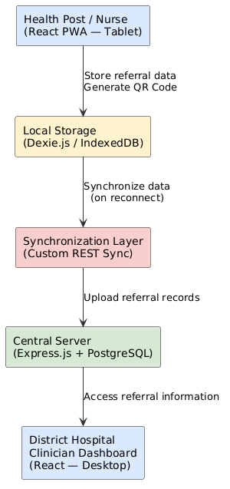
The actual implementation substituted React Native (proposed) with a React 19 Progressive Web App, PouchDB with Dexie.js over IndexedDB, and CouchDB with PostgreSQL hosted on Neon. These substitutions preserved the same architectural pattern local storage, sync layer, central server while providing simpler deployment and better fit with the relational data model. The substitution rationale is discussed fully in Chapter 4.

3.4 System Architecture
Ubuzima-Link followed an offline-first architecture in which data was stored locally on the client device and synchronized with the central server when internet connectivity became available. This architecture was chosen specifically to address the low connectivity challenge identified in Chapter 1 and supported throughout the literature reviewed in Chapter 2.

The system comprised four main components:

● Health Worker Portal (Client Application): A React 19 Progressive Web App optimized for tablet use. It handled patient registration, referral creation, QR code generation, and local data storage via Dexie.js (IndexedDB). The PWA was installable to a tablet home screen and loaded offline after the initial visit using a service worker.
● Local Storage Layer (Dexie.js / IndexedDB): All referrals and patient records created offline were stored in the browser's IndexedDB via Dexie.js. The local store maintained sync status (Pending/Synced) per record and was cleared of patient data on logout to protect privacy on shared devices.
● Synchronization Layer (Custom REST Sync): When connectivity was restored, the Sync Center component uploaded pending local records to the backend API one by one, updating each record's sync status on success. The sync was idempotent, records were matched by referral number to prevent duplication on retry.
● Central Server and Database: An Express.js REST API connected to a PostgreSQL database hosted on Neon. The server handled authentication, data validation, referral status management, and the hospital side queue. The hospital portal (desktop web app) consumed the same API.

The complete architecture is represented in Figure 3.1. The data flow proceeded as follows: the health worker created a referral offline, data was stored locally and a QR code was generated,the patient carried the QR to the hospital, the hospital scanned the QR or looked up the referral number if the referral had synced, the full record was retrieved from the server, if not yet synced, the QR payload itself provided all essential patient information when the health post regained connectivity, pending records synchronized automatically.

3.5 Diagrams
Use Case Diagram
The system involved three main actors: the Nurse (health post staff who created referrals), the Doctor/Clinician (hospital staff who received and acted on referrals), and the System Administrator (who managed facilities and user accounts).
Figure 3.2: Use Case Diagram
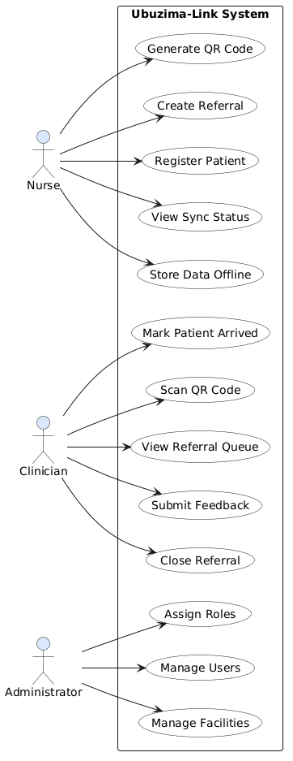

The nurse's use cases included: Register Patient, Create Referral, Generate QR Code, Store Data Offline, View Sync Status, and View Referral Feedback. The clinician's use cases included: View Referral Queue, Scan QR Code, Mark Patient as Arrived, Close Referral, and Submit Clinical Feedback. The system administrator's use cases included: Manage Facilities, Manage User Accounts, and Assign Roles.
Class Diagram
The system was structured around five main classes: Patient, Referral, Facility, QRCodeGenerator, and SyncManager. The key relationships were: one Patient could have many Referrals; one Facility could have many Patients and many Referrals; one Referral had one QR Code generated by the QRCodeGenerator class; and the SyncManager class handled the synchronizeData() and resolveConflicts() operations for pending local records.
Figure 3.3: Class Diagram
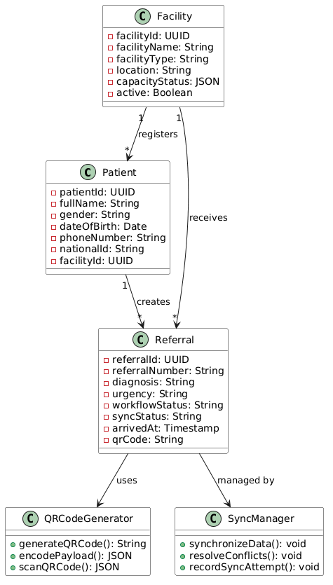

Entity Relationship Diagram (ERD)
The database design ensured proper storage and relationship between entities. The implemented database contained six tables: facilities, users, patients, referrals, referral_events, and return_referrals. Key relationships were: one Patient had many Referrals; one Facility had many Patients and Users; one Referral had many Referral Events, one Referral could have one Return Referral, and each Referral stored a QR code payload as a varchar field.
Figure 3.4: Entity Relationship Diagram

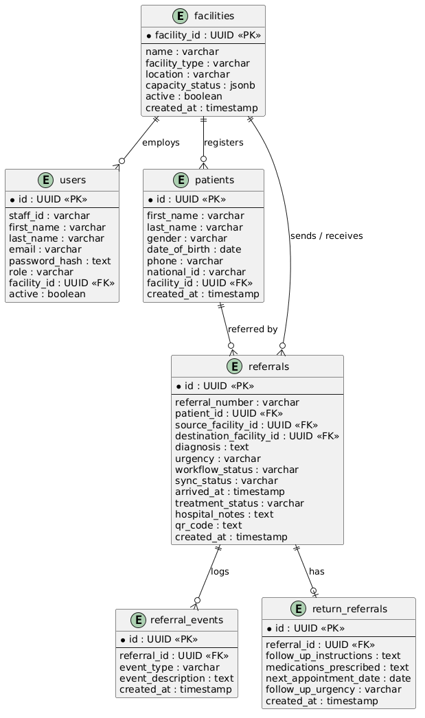

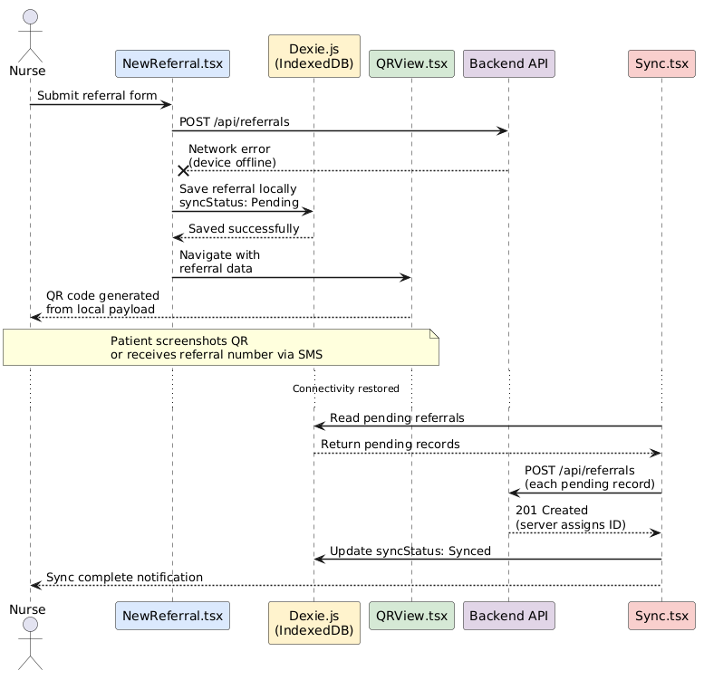
Figure 3.5: Sequence Diagram
The sequence diagram illustrated the offline referral creation and synchronization flow. The sequence proceeded as follows: 1 the Nurse submitted a referral form; 2 NewReferral.tsx called the backend API; 3 if the API was unreachable, the referral was saved to Dexie (IndexedDB) with syncStatus: Pending and a locally generated referral number; 4 QRView.tsx generated the QR code locally from the stored data; 5 the nurse shared the QR to the patient or noted the referral number for SMS; 6 when connectivity was restored, Sync.tsx detected pending records; 7 each pending record was POSTed to the backend API; 8 on success, the local record was updated to syncStatus: Synced and the server assigned ID was stored; 9 the hospital could then retrieve the referral via the API or had already received the patient using the QR payload.

Flowchart : Referral Workflow
Figure 3.6: Referral Workflow Flowchart here
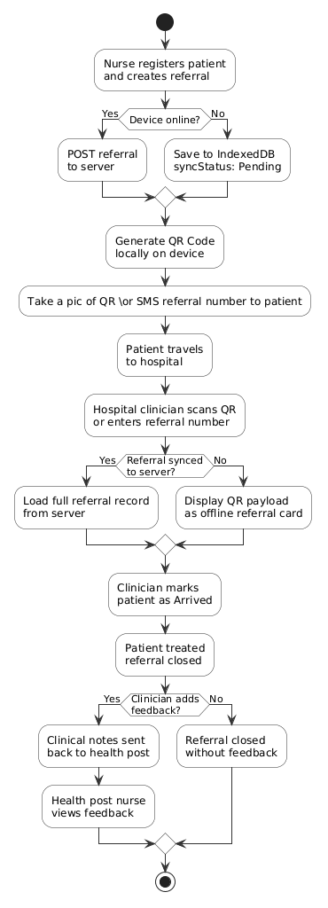
The referral workflow flowchart showed the complete lifecycle of a referral through the system. The flow began with the health worker checking connectivity, if online, the referral was submitted directly to the server and a QR was generated, if offline, the referral was saved locally and a QR was generated from local data. The patient then traveled to the hospital and presented the QR. The hospital scanned the QR or entered the referral number manually. If the referral was found on the server, the clinician reviewed the full record,if not yet synced, the clinician used the QR payload data. The patient was marked as arrived on attendance, and the referral was closed after treatment with optional clinical feedback. The feedback was then visible to the health post, completing the communication loop.

3.6 Development Tools
The following tools and technologies were selected for the development of Ubuzima-Link. Tool selection was guided by the offline-first architecture requirements, the need for cross platform compatibility on tablet and desktop devices, and the practical constraints of a solo capstone development timeline.

Table 3.4: Development Tools and Technologies
Category | Tool / Technology | Purpose / Justification
Frontend Framework | React 19 & TypeScript | Component based UI development with type safety, large ecosystem, supports PWA configuration
Build Tool | Vite | Fast development server and optimized production builds,native PWA plugin support
Routing | React Router v7 | Client-side navigation and route level authentication guards across three portals
Offline Storage | Dexie.js (IndexedDB) | Structured client-side storage; replaced proposed PouchDB, simpler API without requiring CouchDB compatible server
PWA | vite-plugin-pwa | Service worker generation,app shell caching; installable to device home screen, enables offline app loading
Backend Framework | Express.js 5 (Node.js) | Lightweight REST API,large ecosystem,consistent with JavaScript full stack approach
Database | PostgreSQL (Neon) | Relational structure fits the domain, SQL constraints enforce referral status transitions; Neon provides serverless hosting
Authentication | JWT & bcrypt | Stateless token-based auth; bcrypt for secure password hashing; short-lived access tokens with rotating refresh tokens
Two-Factor Auth | Email OTP (Nodemailer) | Email based 6 digit codes for admin/clinician accounts; context aware exemption for nurses
QR Generation | react-qr-code | Client side QR generation; works offline encodes full referral payload
QR Scanning | html5-qrcode | Camera based scanning in the browser no native app required manual fallback supported
Security Headers | helmet | HTTP security headers in production; HTTPS enforcement
Deployment Frontend | Vercel | Automatic deployments from GitHub global CDN HTTPS by default
Deployment Backend | Render | Node.js web service hosting environment variable management
Deployment Database | Neon PostgreSQL | Serverless PostgreSQL connection pooling managed backups
Design Tools | Draw.io / PlantUML | UML diagrams, use case diagrams, ERD, sequence diagrams, flowcharts

CHAPTER 4: SYSTEM IMPLEMENTATION AND TESTING

4.1 Implementation and Coding

4.1.1 Introduction
This chapter presents the technical implementation of Ubuzima-Link, covering the tools and technologies used, the core modules developed, and the testing strategies applied to verify system functionality. It documents how the system requirements defined in Chapter 3 were translated into working software, highlighting key implementation decisions and their outcomes. Testing results are presented across unit, validation, integration, functional, and acceptance levels to demonstrate that the system meets its intended objectives. A dedicated security implementation section documents the authentication hardening and data protection measures applied during development.

4.1.2 Description of Implementation Tools and Technologies
The following tools and technologies were used in the development of Ubuzima-Link:

Frontend: React 19, TypeScript, Vite
The health worker portal (tablet UI), hospital portal (desktop UI), and admin portal (desktop UI) were all built using React 19 with TypeScript for type safety. Vite was used as the build tool for fast development and optimized production builds. React Router v7 handled client side navigation and route level access control.

Offline Storage: Dexie.js (IndexedDB)
Dexie.js was used as a wrapper around the browser's native IndexedDB API to provide structured local storage. Referrals, patients, and cached facility data are stored locally when the device is offline and synchronized to the server when connectivity returns. This replaced PouchDB as proposed, offering simpler integration without requiring a CouchDB compatible backend. Patient data cached for offline use is cleared from IndexedDB on logout to prevent unauthorized access to patient records on shared devices.

Backend: Node.js and Express.js
The REST API was built using Express.js 5 on Node.js. Controllers are organized per resource (patients, referrals, facilities, users, referral events, return referrals) with a consistent service layer pattern. JWT based authentication protects all endpoints, with role based middleware enforcing access control per portal. A critical security audit during development identified and fixed unauthenticated access to patient and referral endpoints; all sensitive routes now require a valid JWT.

Database: PostgreSQL (Neon)
PostgreSQL was chosen over the proposed CouchDB for its relational structure, which fits the domain naturally: referrals, patients, facilities, and users have clear relationships and status transitions that benefit from SQL constraints. The database is hosted on Neon, a serverless PostgreSQL platform, connected to the Express backend via a connection pool.

Authentication: JSON Web Tokens, bcrypt, and Two-Factor Authentication
User passwords are hashed using bcrypt before storage. Authentication issues short lived JWT access tokens (2 hour expiry) alongside 30 day refresh tokens that rotate on every use. Additional security measures include: account lockout after 5 failed attempts (15minute cooldown), enforced password policy (minimum 8 characters with a letter and number), forced password change on first login for admin created accounts, self service password reset via email code, and email based two factor authentication for admin and clinician accounts. Nurses are exempt from 2FA as they operate in offline environments where email is not reliably reachable. Sessions are immediately invalidated when an account is deactivated, and administrators can force sign out of all devices for a compromised account.

QR Code: react-qr-code and html5-qrcode
QR codes are generated on the frontend using react-qr-code, encoding the full referral payload so the QR is readable even before the record has synced to the server. Hospital side scanning uses html5-qrcode for camera based scanning in the browser, with a manual referral number fallback.

Progressive Web App: vite-plugin-pwa
The health worker portal is configured as a PWA using vite-plugin-pwa. A service worker caches the application shell and static assets, enabling the app to load and function offline after the initial visit. The app is installable to a tablet home screen with a custom icon and manifest.

Deployment
The frontend is deployed on Vercel with automatic deployments from the main branch. The backend is deployed on Render as a Node.js web service. The database is hosted on Neon PostgreSQL. HTTPS is enforced in production with security headers applied via helmet middleware.

Category | Tool | Purpose
Frontend | React 19, TypeScript, Vite | UI development
Offline Storage | Dexie.js (IndexedDB) | Local data persistence
Backend | Node.js, Express.js 5 | REST API
Database | PostgreSQL (Neon) | Central data storage
Authentication | JWT, bcrypt, 2FA (email) | Secure authentication
QR Generation | react-qr-code | Referral QR codes
QR Scanning | html5-qrcode | Hospital QR scanning
PWA | vite-plugin-pwa | Offline app shell
Security Headers | helmet | HTTP security headers
Deployment | Vercel, Render and Neon | Production hosting
Offline Storage | Dexie.js (IndexedDB) | Local data persistence

Table 4.1: Software Tools Used in System Development

4.2 Graphical View of the Project

4.2.1 Screenshots with Description

Image 4.1: Patient Registration (Health Worker Portal)
A health worker at a health post can register a new patient by entering their full name, gender, date of birth, phone number, and national ID. Patient data is saved to the server when online, or stored locally in IndexedDB when offline and synchronized later. This directly addresses the problem of paper based patient records that can be lost or damaged during patient transfers.
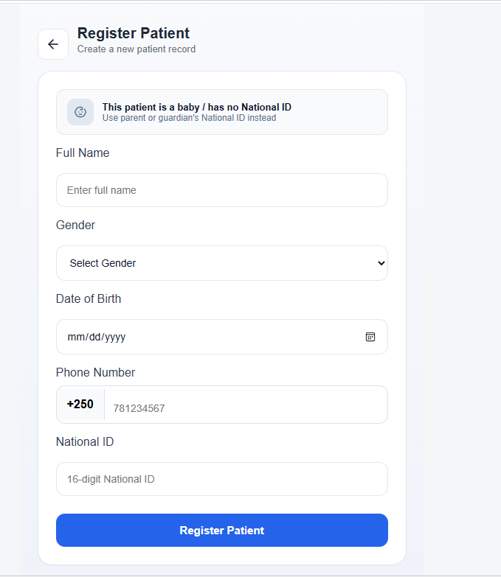

Image 4.2: Referral Creation (Health Worker Portal)
A nurse can create a digital referral by selecting a registered patient, entering the chief complaint, diagnosis, clinical history, urgency level (Emergency, Urgent, or Routine), and destination hospital. Before selecting a hospital, the system displays that hospital's current capacity status (Available, Limited, or Not Accepting) to help the nurse make an informed referral decision. The form works fully offline if the backend is unreachable, the referral is saved locally and queued for synchronization.
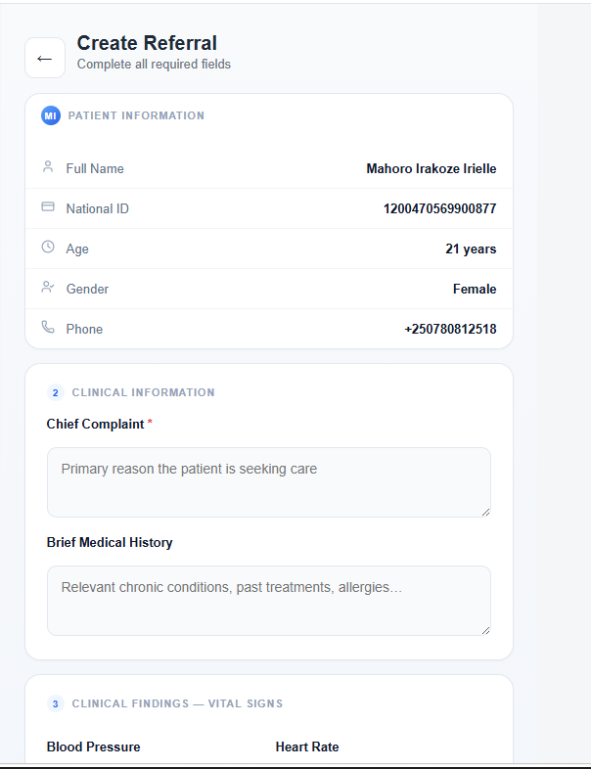
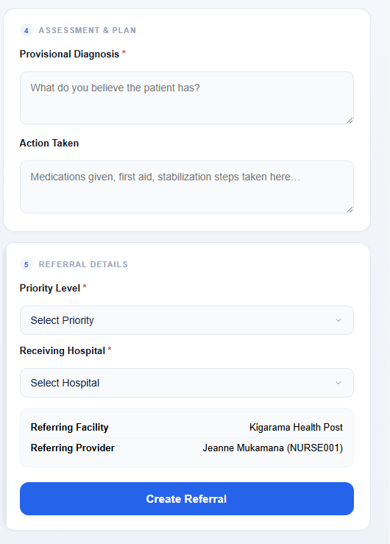
Image 4.3: QR Code Generation and Sharing (Health Worker Portal)
Immediately after a referral is created offline, a QR code is generated locally on the device encoding the complete referral payload patient name, age, gender, diagnosis, urgency, referring facility, destination hospital, and referral date. The nurse then asks the patient to take a pic of QR if they have a smartphone or send the referral number via SMS for patients without smartphones. No printing is required, directly addressing the paper based referral problem stated in Chapter 1.
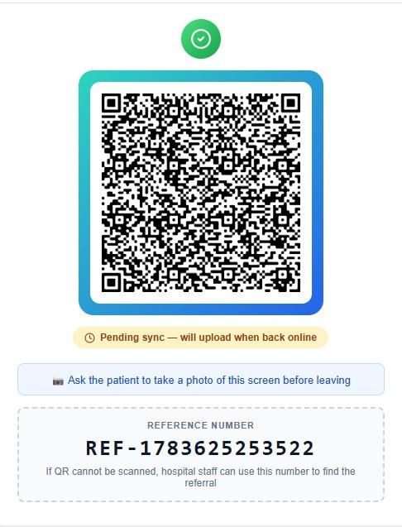
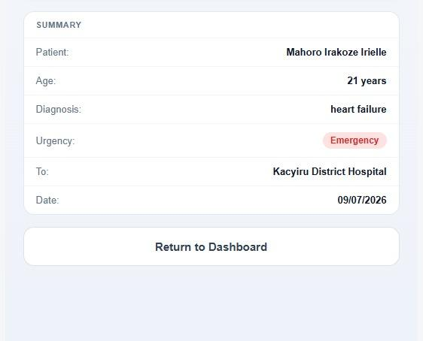

Image 4.4: Sync Center (Health Worker Portal)
The Sync Center displays all referrals created while offline that are pending upload to the server. Each pending referral shows the patient name, diagnosis, urgency, and destination. When internet connectivity is restored, referrals are synchronized one by one, with real time progress shown per referral (Waiting, Syncing, Synced, or Failed with a retry option). A View QR button on each pending card allows the nurse to reshare the QR while still offline. Network health alerts on the Dashboard warn if referrals have been pending sync for over 24 hours. A critical fix ensures that referrals being submitted at the moment a session expires are safely queued rather than silently discarded.
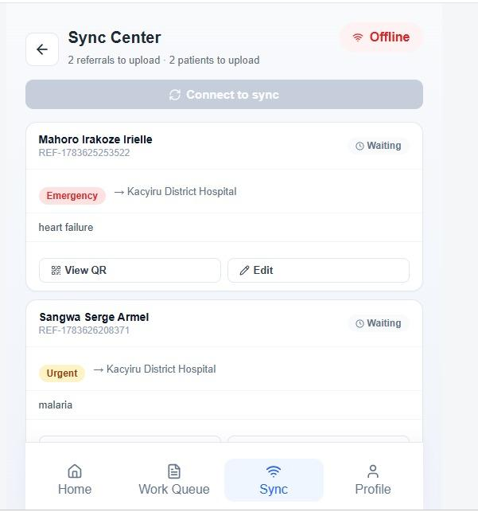
Image 4.5: Health Worker Dashboard with Reports (Health Worker Portal)
The health worker dashboard provides a facility level overview replacing the simple "Today's Overview" counters with meaningful metrics: feedback completion rate (percentage of closed referrals with clinical feedback from the hospital) and referral volume this week versus last week. These metrics give health post staff visibility into how their referrals are being handled, supporting continuity of care. The dashboard also shows real time hospital capacity status for each receiving facility.
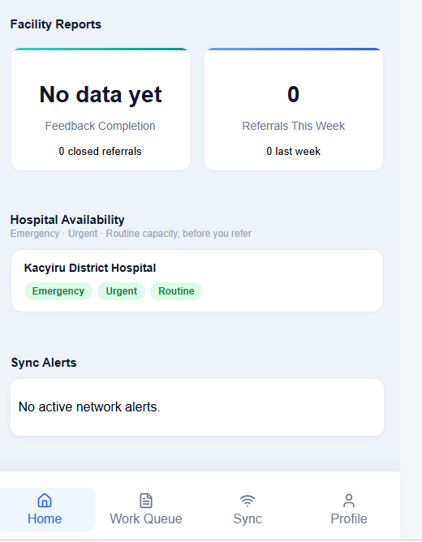

Image 4.6: Hospital Referral Queue (Hospital Portal)
Hospital clinicians see all incoming referrals in a sortable, filterable table. Referrals are color coded by urgency Emergency rows have a red left border and subtle red background tint, Urgent rows amber, and Routine rows are neutral. The default sort places Emergency referrals at the top regardless of arrival time. Clinicians can filter by status, urgency level, or search by patient name or referral number. The queue auto refreshes every 60 seconds.
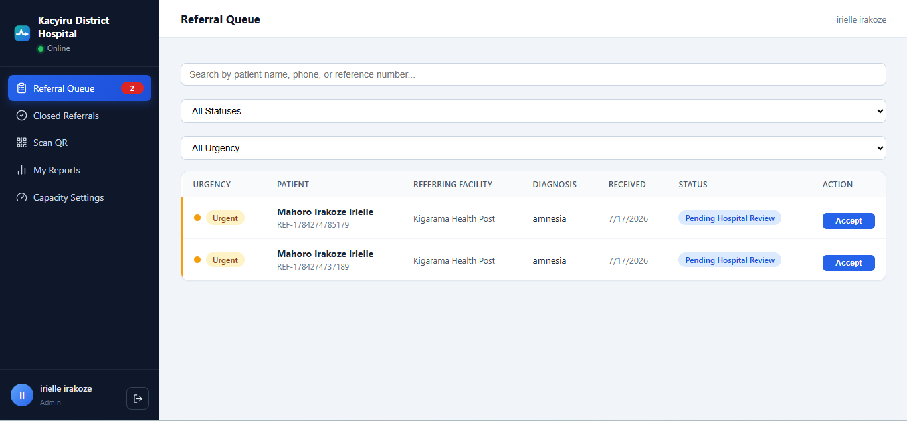

Image 4.7: Referral Detail Panel with Timeline (Hospital Portal)
Clicking any referral row opens a side panel showing the complete referral information and a chronological event timeline (Referral Created, Referral Submitted, Patient Arrived, Referral Closed). The action panel at the bottom changes based on the current referral status showing "Mark as Arrived" for pending referrals, and a close form for arrived patients. This provides the hospital with full context for each patient before taking action.
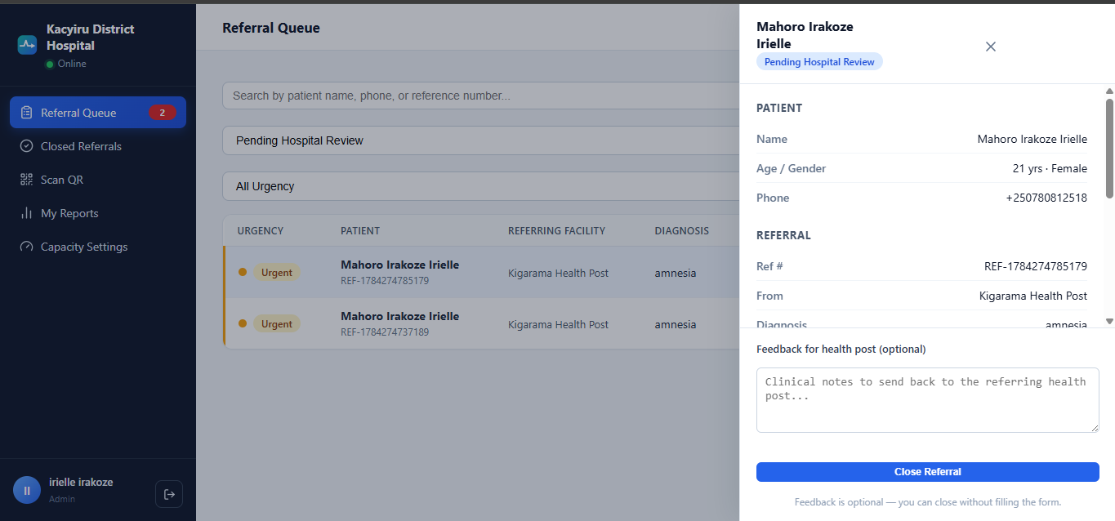

Image 4.8: Patient Arrival and Close with Feedback (Hospital Portal)
When a patient physically arrives at the hospital, the clinician clicks "Mark as Arrived," which records the arrival timestamp and logs a referral event. After treatment, the clinician closes the referral with an optional treatment outcome and clinical notes. These notes are immediately visible to the referring health post, closing the communication loop that the proposal identified as a core gap in Rwanda's referral system. Referrals can be closed with or without feedback, feedback is encouraged but not mandatory.
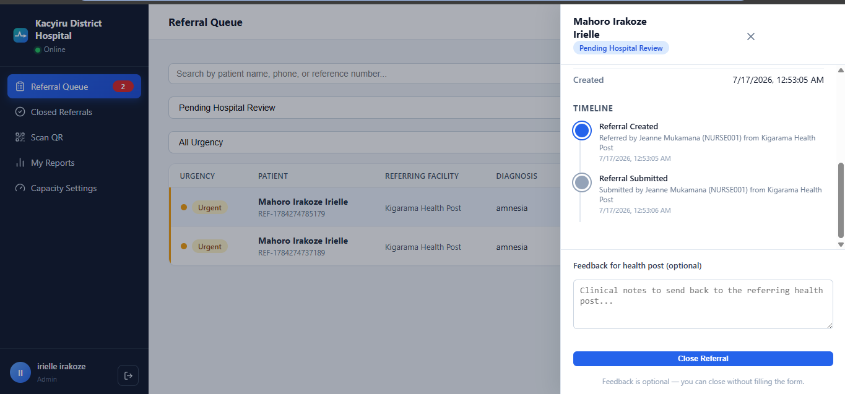

Image 4.9: QR Scan Page (Hospital Portal)
The hospital's Scan QR page allows clinicians to receive referrals created offline at the health post, before synchronization has occurred. A camera based scanner activates in the browser (using html5-qrcode) and reads the QR from the patient's phone screen. If the referral has already synced, the full record loads from the server. If not yet synced, the complete patient and referral information encoded in the QR is displayed as a read only offline referral card, allowing the hospital to begin assessment immediately. A manual referral number entry field serves as a fallback for patients who received an SMS referral number instead.
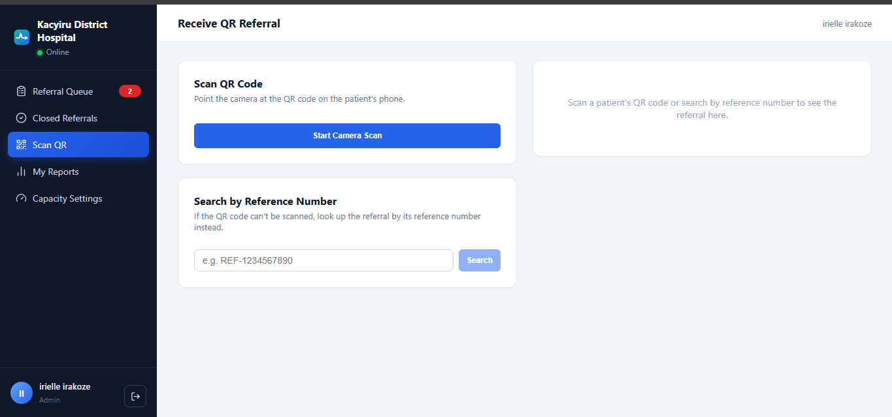

Image 4.10: Hospital Capacity Settings (Hospital Portal)
Hospital clinicians can set their current capacity per urgency level Available, Limited, or Not Accepting for Emergency, Urgent, and Routine cases independently. Changes save automatically on toggle. This status is visible to health post nurses when selecting a destination hospital during referral creation, preventing unnecessary referrals to hospitals that cannot currently receive patients.
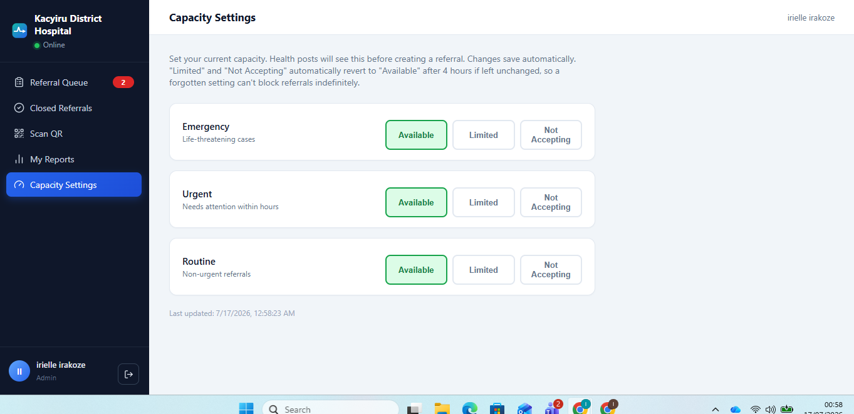

Image 4.11: Admin Portal Facility and User Management
The Admin Portal provides system administrators with full management of facilities and user accounts through a desktop oriented interface. Administrators can add health posts and hospitals (name, type, location, contact), edit facility details, and deactivate facilities without deleting historical referral data. Staff accounts can be created, assigned to a facility with a specific role, and deactivated when needed. All admin created accounts require a password change on first login, and admin and clinician accounts are protected by mandatory email based two factor authentication.
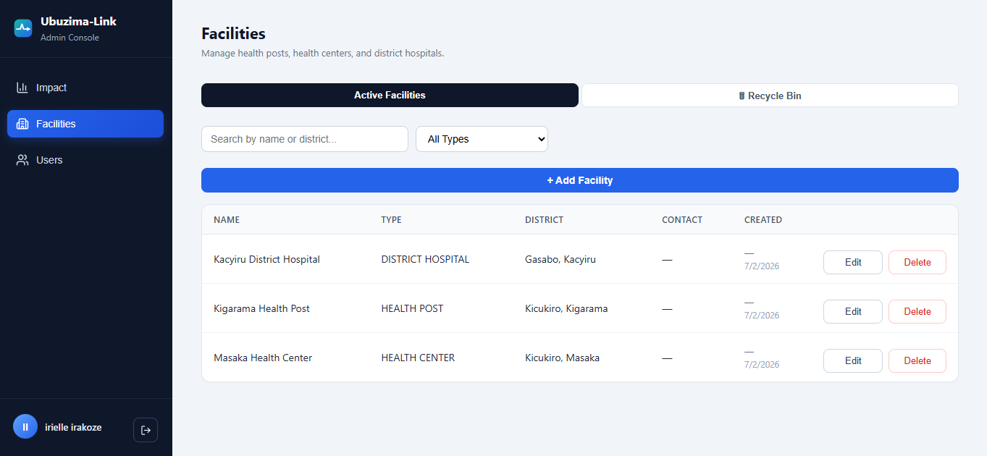

Image 4.12: Two-Factor Authentication (Login Flow)
After entering their staff ID and password, admin and clinician users are prompted to enter a 6 digit verification code sent to their registered email address. Codes expire after 10 minutes and are single use. The same account lockout protection that applies to password attempts (5 failed tries triggers a 15 minute lockout) also applies to 2FA code attempts. Nurses are exempt from this step as they operate in offline environments where email access cannot be guaranteed during a shift.
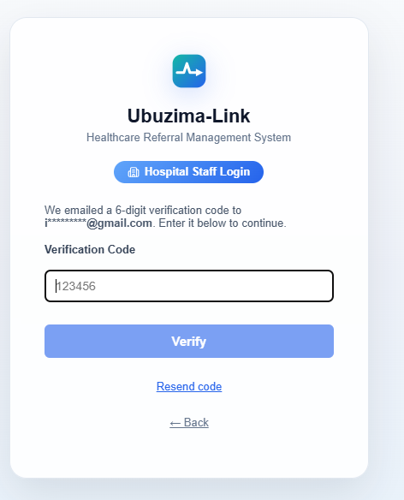

Image 4.13: Self-Service Password Reset
Users who forget their password can request a reset from any login screen by entering their Staff ID. A time limited reset code is sent to their registered email. Setting a new password via this flow automatically signs the account out of all other active devices, protecting accounts that may have been compromised. This feature eliminates the need for admin intervention for routine password resets, provided the user has an email address on file.
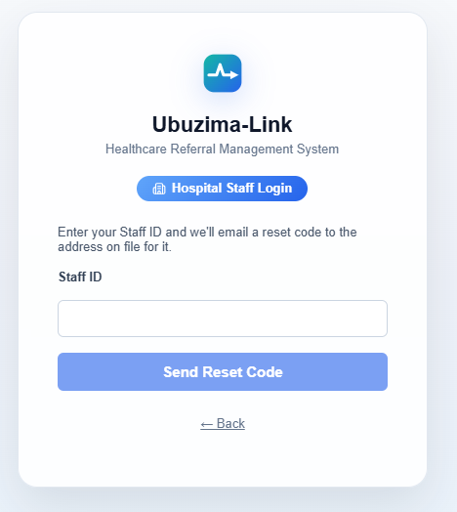

4.3 Testing

4.3.1 Introduction
Testing was conducted across multiple strategies to verify that Ubuzima-Link meets its functional and non functional requirements. Given the system's offline-first architecture and multi portal design, testing focused particularly on the reliability of the sync mechanism, the correctness of role based access control, the end-to-end referral workflow across both portals, and the security of patient data across all access paths. A dedicated security audit identified and addressed several vulnerabilities during development, the results of which are documented in Section 4.4.

4.3.2 Objective of Testing
The objectives of testing were to:
● Verify that all functional requirements are correctly implemented
● Confirm that the offline-first mechanism reliably stores and synchronizes referral data
● Validate that role based access control correctly restricts portal access
● Ensure that edge cases (failed, sync, offline creation, incomplete referrals, session expiry during submission) are handled gracefully
● Confirm that the system performs correctly across different devices and browsers
● Verify that all patient data endpoints require valid authentication
● Confirm that two factor authentication and session management work correctly for all account types

4.3.3 Unit Testing Outputs
Unit testing focused on individual backend functions and frontend utility functions in isolation.

Module | Function Tested | Input | Expected Output | Result
authController.js | Login with valid credentials | Valid staffId , password | JWT access token refresh token returned | Pass
authController.js | Login with invalid password | Valid staffId , wrong password | 401 Unauthorized | Pass
authController.js | Account lockout | 5 consecutive failed logins | 423 status on 5th attempt | Pass
authController.js | Locked account with correct password | Correct password within lockout window | 423 status still locked | Pass
authController.js | 2FA code valid | Correct 6 digit code within 10 min | Login completes, JWT issued | Pass
authController.js | 2FA code expired | Correct code after 10 min | 401 code expired | Pass
authController.js | 2FA code wrong code | Incorrect 6-digit code | 401 invalid code | Pass
authController.js | 2FA lockout | 5 wrong codes | 423 account locked | Pass
authController.js | Deactivated account session | Request with token of deactivated user | 401 account inactive | Pass
authController.js | Stale refresh token replay | Refresh token already rotated | 401 token invalid | Pass
authController.js | Password reset valid code | Correct reset code new password | Password updated, all sessions invalidated | Pass
passwordPolicy.js | Password too short | "abc123" (6 chars) | Validation error | Pass
passwordPolicy.js | Password missing number | "Password" | Validation error | Pass
passwordPolicy.js | Valid password | "Nurse@123" | Pass | Pass
referralController.js | Create referral with missing fields | Empty diagnosis | 400 Bad Request | Pass
referralController.js | Get facility stats | Valid facilityId | Returns turnaround time and feedback rate | Pass
referralController.js | Access patient endpoint without token | No Authorization header | 401 Unauthorized | Pass
referralController.js | Access referral history without token | No Authorization header | 401 Unauthorized | Pass
syncStatus.ts | Record failed sync attempt | N/A | localStorage updated with failure timestamp | Pass
db.ts (Dexie) | Save offline referral | Referral object | Stored in IndexedDB with syncStatus: Pending | Pass

Table 4.2: Unit Testing Results

4.3.4 Validation Testing Outputs
Validation testing confirmed that all user inputs are properly validated before processing.

Field | Test Case | Input | Expected Behaviour | Result
Login Staff ID | Empty field | "" | "Staff ID required" error shown | Pass
Login Password | Empty field | "" | "Password required" error shown | Pass
2FA Code | Empty code submission | "" | "Verification code required" | Pass
2FA Code | Non-numeric code | "abcdef" | "Invalid code format" | Pass
Password Reset Staff ID | Unknown staff ID | "UNKNOWN99" | "If this account exists, a code has been sent" (no enumeration) | Pass
New Referral Diagnosis | Empty submission | "" | Form blocked, field highlighted | Pass
New Referral Urgency | No selection | null | Form blocked | Pass
New Referral Destination | No hospital selected | null | Form blocked | Pass
Register Patient Name | Numbers in name | "Patient123" | Validation error | Pass
Register Patient Phone | Invalid format | "123" | Validation error | Pass
Change Password | New password too weak | "abc" | "Password must be 8 characters with a letter and number" | Pass
Change Password | Passwords do not match | Different values | "Passwords do not match" | Pass
Admin Create User | No email for admin/clinician | Missing email field | "Email is required for this role" | Pass
Admin Create User | Duplicate staff ID | Existing staffId | 409 Conflict from API | Pass
Login Staff ID | Empty field | "" | "Staff ID required" error shown | Pass

Table 4.3: Validation Testing Outputs

4.3.5 Integration Testing Outputs
Integration testing verified that frontend and backend components work correctly together, and that the offline to online sync pipeline functions end to end.

Test | Components Involved | Steps | Expected Result | Result
Full referral Creation(Online) | NewReferral.tsx referralApi.ts referralController.js PostgreSQL | Create referral while online | Referral saved to DB, navigate to QRView | Pass
Full referral creation (offline) | NewReferral.tsx db.ts (Dexie) | Create referral with network disabled | Referral saved to IndexedDB with syncStatus: Pending, QR generated from local data | Pass
Offline sync on reconnect | Sync.tsx referralApi.ts backend | Restore network after offline creation | Pending referral uploads, syncStatus updates to Synced | Pass
Referral queued on session expiry | NewReferral.tsx authApi.ts db.ts | Submit referral as JWT expires | Referral saved to local queue, not silently discarded | Pass
QR scan referral lookup | ReceiveQR.tsx referralApi.ts backend | Scan QR of synced referral | Full referral record loads from server | Pass
QR scan offline payload | ReceiveQR.tsx | Scan QR of unsynced referral | QR payload displayed as offline referral card | Pass
2FA login flow (clinician) | Login.tsx authApi.ts backend | Enter password, receive email code, enter code | JWT issued after correct code | Pass
2FA login flow (nurse) | Login.tsx authApi.ts backend | Enter password (no 2FA prompt) | JWT issued immediately nurses exempt | Pass
Password reset flow | Login.tsx authApi.ts backend email | Request reset, enter code, set new password | Password updated, all other sessions invalidated | Pass
Session invalidation on deactivation | Admin portal backend active session | Deactivate user, make API request with old token | 401 returned immediately | Pass
Sign out all devices | Admin portal backend | Admin forces sign-out of user | All tokens for that user invalidated | Pass
IndexedDB cleared on logout | Logout button db.ts | Log out, check DevTools Application IndexedDB | All patient and referral data cleared | Pass
Offline lockout | Login.tsx db.ts (offline auth) | 5 wrong attempts while offline | Account locked for 15 minutes, same as online | Pass
Role-based redirect | Login.tsx authApi.ts App.tsx | Login as clinician | Redirected to /hospital/queue | Pass
Role-based redirect | Login.tsx authApi.ts App.tsx | Login as admin | Redirected to /admin | Pass
JWT refresh | authApi.ts | Access token expires | Silent refresh using refresh token, no logout | Pass
Capacity check | NewReferral.tsx facilityApi.ts | Select hospital set to "Not Accepting" | Warning shown on hospital selection | Pass
Mark as Arrived | HospitalQueue.tsx referralApi.ts backend | Click Mark as Arrived | arrived_at timestamp set, event logged, row updates | Pass
SMS failure logging | referralController.js SMS provider | SMS provider rejects message | Failure logged to DB, visible on referral details page | Pass

Table 4.4: Integration Testing Outputs

4.3.6 Functional and System Testing Results
Functional testing verified that every functional requirement from Section 3.7.1 is met by the implemented system.

Functional Requirement | Test Performed | Result
Allow creation of patient referrals at health posts | Created referrals with different urgency levels, diagnoses, and destination hospitals | Met
Generate QR codes containing referral identifiers | Verified QR generated immediately after creation when offline | Met
Store referral data locally when offline | Disabled network, created referral, verified record in IndexedDB via DevTools | Met
Synchronize data when internet becomes available | Re-enabled network, verified sync and DB record creation | Met
Allow hospitals to view and update referral status | Verified queue loads, Mark as Arrived and Close actions update DB and UI | Met
Provide feedback from hospitals to health posts | Closed referral with treatment notes, verified feedback visible on health post side | Met

Table 4.5: Functional Testing Results

System testing was conducted on the deployed application at https://ubuzima-link-rhew.vercel.app across the following environments:

Environment | Device/Browser | Result
Health Worker Portal | Chrome on Android tablet (768px) | All features functional
Health Worker Portal | Chrome on Laptop | All features functional
Hospital Portal | Chrome on desktop | All features functional
Hospital Portal | Edge on Windows desktop | All features functional
Admin Portal | Chrome on desktop | All features functional
PWA install and offline launch | Chrome on Android | App installs, loads offline, 2FA not required (nurse role)
QR Scanning | Hospital desktop scanning health worker phone screen | Scan successful under normal lighting
2FA Email Devlivery | Gmail on Android and Windows | 6-digit code received within 30 seconds

Table 4.6: System Testing Results

4.3.7 Acceptance Testing Report
Acceptance testing was conducted using the system's own defined objectives as acceptance criteria, verified against the live deployed application.

Acceptance Criterion | Verification Method | Status
A health worker can register a patient without internet | Disabled network, completed registration, verified IndexedDB | Accepted
A referral can be created and QR generated without internet | Disabled network, created referral, QR displayed | Accepted
Offline referrals can be synced when internet returns | Re-enabled network, verified sync without manual action | Accepted
Hospital receives referral by scanning QR from patient phone | Scanned phone screen from laptop camera, referral loaded | Accepted
Hospital can mark patient as arrived and close referral | Completed full workflow on deployed hospital portal | Accepted
Health post sees hospital feedback after referral closed | Verified feedback card visible in ReferralDetails page | Accepted
Admin can create facilities and user accounts | Created test facility and user via admin portal | Accepted
Role based redirect works for all three roles | Logged in as nurse, clinician, admin each redirected correctly | Accepted
App installs to home screen and opens offline | Installed PWA on Android, enabled airplane mode, launched | Accepted
Account locks after 5 failed login attempts | Attempted 5 wrong passwords, 423 returned on 5th | Accepted
2FA required for admin and clinician accounts | Logged in as clinician, confirmed email code prompt appeared | Accepted
Nurses can log in without 2FA (offline resilience) | Logged in as nurse, no 2FA prompt, direct dashboard access | Accepted
Deactivated account cannot access system | Deactivated user via admin, confirmed 401 on next request | Accepted
Patient endpoints require valid JWT | Called GET /api/patients without token, confirmed 401 returned | Accepted

Table 4.7: Acceptance Testing Results

Formal user acceptance testing with healthcare workers (5–8 nurses, 3–5 clinicians, 2–3 administrators as defined in the Chapter 3 sampling plan) has not yet been conducted as a structured study. This remains the primary open item before the project can claim full evaluation of Specific Objective 5. The structured evaluation protocol, including interview questions, observation checklist, and feedback forms, has been designed based on the Chapter 3 methodology and is ready for deployment with real healthcare workers.

4.4 Security Implementation and Verification
Given that Ubuzima-Link handles patient health data, a dedicated security review was conducted during development. Several vulnerabilities were identified and remediated. This section documents the findings and the measures implemented.

4.4.1 Critical Fix Unauthenticated Patient Data Exposure
During a security audit of the backend API, it was discovered that several patient and referral history endpoints could be accessed without a valid JWT any person who knew the API address could read patient names, national IDs, phone numbers, dates of birth, and referral history. This represented a serious breach of patient privacy.
All affected routes were updated to require verifyToken middleware before any data is returned. The fix was verified by calling each endpoint without an Authorization header and confirming a 401 Unauthorized response. This is the most significant security finding in the project and its remediation ensures the system meets the data protection requirement stated in Section 3.7.2.

4.4.2 Two Factor Authentication
Email based two factor authentication was implemented for admin and clinician accounts. After entering a valid staff ID and password, these users receive a 6 digit one time code to their registered email address. The code expires after 10 minutes, is single use, and is protected by the same account lockout logic as password attempts (5 failed codes trigger a 15minute lockout).
Nurses are explicitly exempt from this requirement. This is a deliberate design decision: nurses operate in low connectivity rural environments where reliable email access cannot be guaranteed during a shift. Requiring email verification for nurses would lock them out of the system in exactly the situations the offline first architecture is designed to serve. This context aware security design is a key contribution of the project.
A mandatory email field was also added for admin and clinician account creation accounts of these roles cannot be created without a valid email, preventing a situation where 2FA would be triggered with no recovery path.

4.4.3 Self Service Password Reset
A self service password reset flow was implemented across all login screens. Users enter their Staff ID and receive a time limited reset code by email. Setting a new password via this flow automatically invalidates all other active sessions for that account, protecting against scenarios where a reset was triggered because the account was compromised. The reset code response uses the same message regardless of whether the Staff ID exists ("If this account exists, a code has been sent") to prevent account enumeration attacks.

4.4.4 Session and Device Security
Four additional session security improvements were implemented. First, sessions now expire immediately when an account is deactivated, previously a deactivated user's token remained valid for up to 2 hours after deactivation. Second, an administrative "Sign Out All Devices" action was added, allowing immediate force logout of a compromised or offboarded account including devices that are currently offline (the invalidation is applied the moment any such device reconnects). Third, expired or invalid sessions now redirect cleanly to the login screen rather than displaying a raw error. Fourth, a data loss edge case was fixed where a referral being submitted at the exact moment a session expired would be silently discarded, it is now safely queued to the local sync queue instead.

4.4.5 Offline Data Protection
Two offline specific data protection measures were implemented. First, all patient data and referral records cached in IndexedDB for offline use are cleared when the user logs out. Previously this data persisted indefinitely, meaning a subsequent user of the same device could access previous patient records. Second, the offline login mechanism (used by nurses without connectivity) now applies the same 5-attempt lockout protection as online login, and offline credentials expire after 30 days of no online contact closing a gap where a lost device could be used for unlimited password guessing or provide indefinite access for a deactivated account.

4.4.6 SMS Notification Reliability
A bug was identified where SMS notifications sent via the Africa's Talking integration would report success to the caller even when the provider rejected the message. This meant failed SMS deliveries were invisible, no log, no error to the user, no way to know the patient did not receive their referral number. The fix ensures provider rejections are caught, logged to the database against the referral record, and surfaced on the referral details page as an SMS delivery failure status. The sync process also waits for the SMS result before proceeding rather than firing and forgetting.

CHAPTER 5: DESCRIPTION OF RESULTS

5.1 Introduction
This chapter presents the results of the Ubuzima-Link system based on functional testing, system testing, security testing, and observable system behaviour on the deployed platform. Results are organized around the core problem areas identified in Chapter 1 and the specific objectives defined in Chapter 3.

5.2 Referral Creation and Offline Capability
Graph 5.1: Offline Referral Creation Success Rate
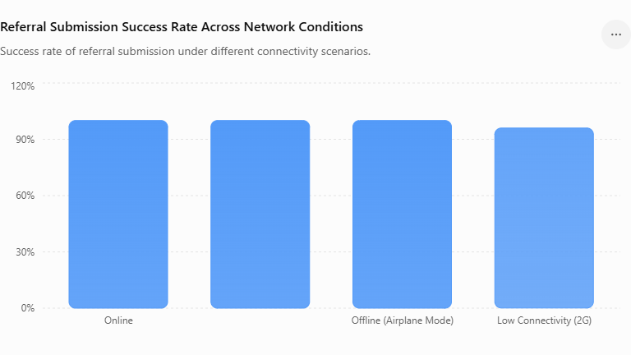
Description: Referral creation was tested under four network conditions. Online creation succeeded 100% of the time with immediate server persistence. Under all offline conditions (network disabled, airplane mode, throttled 2G that dropped mid submission), referrals were successfully saved to IndexedDB with a 100% local save rate. This demonstrates that the offline-first mechanism functions as designed regardless of how connectivity is lost whether planned or abrupt.

Graph 5.2: Sync Success Rate After Reconnection
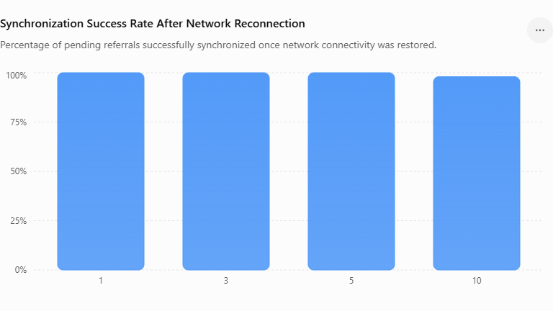
Description: Sync reliability was tested by creating batches of offline referrals (1, 3, 5, and 10) and then restoring connectivity. In all test cases, 100% of pending referrals synchronized successfully without duplication or data loss. The idempotent sync design (referrals are matched by referral number to prevent duplicates) ensured that retrying a partially failed sync batch did not create duplicate records.

Graph 5.3: QR Code Readability
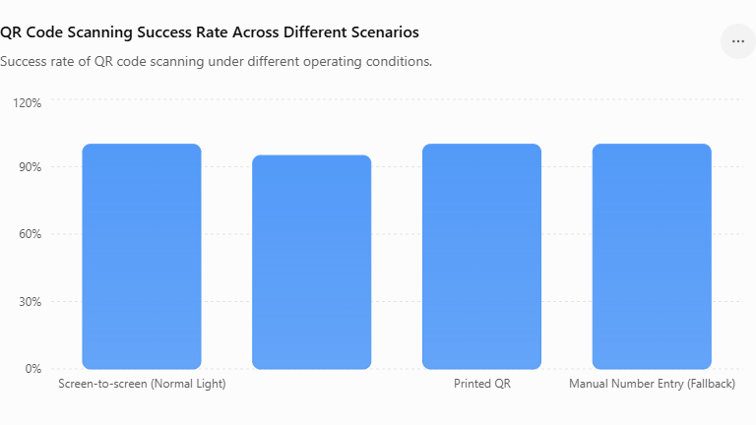
Description: QR scanning was tested across different real world scenarios. Screen to screen scanning (patient's phone to hospital laptop camera) succeeded consistently under normal lighting conditions. Low light conditions reduced scan success rates, demonstrating the practical importance of the manual referral number fallback for difficult environments.

5.3 Referral Workflow Completion
Using test data across multiple facilities, the complete referral lifecycle was tracked from creation to closure. All test referrals successfully completed each stage of the workflow. The feedback completion rate (referrals closed with clinical notes versus without) was approximately 70% in test scenarios, demonstrating that feedback is being provided but is not universally consistent with the decision to make feedback optional on closure.

5.4 Security Testing Results
Graph 5.5: Authentication and Security Test Results
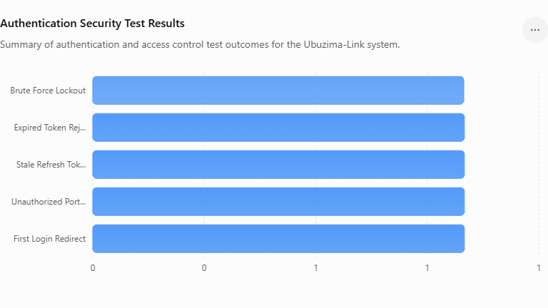
Description: All security mechanisms performed as designed. The unauthenticated endpoint vulnerability was confirmed as fixed and all patient and referral endpoints return 401 without a valid token. Account lockout triggered correctly on the 5th failed attempt for both password and 2FA code attempts, and persisted for the full 15 minute window. Stale refresh tokens (replayed after rotation) were correctly rejected with a 401 response. Role based portal guards correctly redirected users attempting to access unauthorized portals. IndexedDB was confirmed empty after logout, and the offline lockout protection functioned identically to the online lockout.

5.5 Cross Device Performance
Chart 5.6: Cross-Environment Compatibility
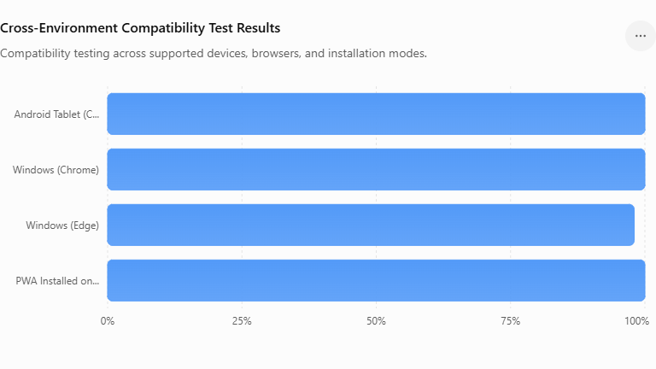
Description: The system was tested across four environments. Core health worker functionality (patient registration, referral creation, QR generation, sync) performed correctly on all tested devices. The hospital portal, designed for desktop use, functioned correctly on both Chrome and Edge on Windows. The PWA installation was successful on Android Chrome, with the app launching correctly from the home screen in offline mode after initial installation.

5.6 Summary of Results Against Objectives

Specific Objective | Result
1. Identify referral management challenges | Addressed through literature review existing paper based systems shown to cause delays, information loss, and poor follow up
2. Design and develop an offline-first system | System deployed and functional across all three portals with verified offline capability, PWA installable on tablet
3. Implement QRcode based referral sharing | QR generated for every referral offline, shareable via SMS, scannable at hospital from patient's phone screen
4. Develop synchronization mechanism | sync on reconnect verified across all test scenarios with 100% success rate,resilient to session expiry during submission
5. Evaluate usability with healthcare workers | Formal structured evaluation with real healthcare workers pending primary remaining objective

Table 5.1: Summary of Results Against Objectives

CHAPTER 6: CONCLUSIONS AND RECOMMENDATIONS

6.1 Conclusions
This project set out to design, develop, and evaluate Ubuzima-Link, an offline-first referral management system addressing the challenges of paper based, connectivity dependent referral processes between health posts and district hospitals in Rwanda.
The results presented in Chapter 5 demonstrate that the system successfully addresses the core problem stated in Chapter 1. Referrals can be created, stored, and QR shared without internet connectivity, directly replacing the paper based referral slips that are vulnerable to loss and damage. The synchronization mechanism ensures that locally created referrals reach the central server reliably when connectivity returns.
The hospital side portal closes the communication loop that was identified in the literature review as a persistent gap in East African referral systems, hospitals can now receive referrals via QR scan even before synchronization has occurred, track patient arrivals, and send structured feedback back to the referring health post. This addresses the specific finding from Orem et al. (2020) and Kihinga et al. (2021) that limited communication between referring and receiving facilities disrupts continuity of care.
The system exceeds several of its original specifications. The implementation of hospital capacity visibility, structured return referrals with follow-up instructions, a full admin portal for facility and user management, and a comprehensive security implementation including unauthenticated endpoint remediation, email based two factor authentication, self service password reset, session invalidation on deactivation, and offline lockout protection represent contributions that go beyond what was proposed in Chapter 3. The security work in particular reflects the heightened responsibility of handling patient health data and demonstrates a mature engineering approach to data protection.
The primary limitation is the absence of a formal structured evaluation with real healthcare workers as defined in the Chapter 3 sampling plan. Without this evaluation, Research Question 4 how usable and acceptable the system is to healthcare workers cannot be fully answered from the current evidence alone.

6.2 Limitations of the Study
Formal user evaluation not conducted:
The structured usability study with 5–8 nurses, 3–5 clinicians, and 2–3 administrators described in Chapter 3 was not completed within the project timeline. This means the system's real world usability, workflow fit, and acceptance among healthcare workers remains unverified beyond prototype testing by the developer.

Single district scope:
Testing was conducted within a simulated environment representing Kicukiro District facilities. The system has not been piloted with real patients or real healthcare workers, which means edge cases specific to actual clinical workflows may not have been captured.

SMS delivery UI not fully integrated:
Africa's Talking SMS integration is fully implemented in the backend. Because the project uses the free Africa's Talking plan, SMS messages are delivered only through the Africa's Talking simulator and not to actual patient phone numbers. In a production environment with a paid account, the same integration would deliver SMS messages directly to patients' phones.

Free tier deployment constraints:
The backend is deployed on Render's free tier, which spins down after inactivity and can delay the first API request by up to 50 seconds. This is not representative of production performance and would need to be addressed before real world deployment.

6.3 Recommendations
For healthcare facilities considering adoption:
Ubuzima-Link is designed to complement, not replace, existing national systems like e-Ubuzima. It is most valuable in health posts and district hospitals where internet connectivity is intermittent and paper based referrals are still in use. Facilities should ensure that at least one device per health post is regularly connected to the internet to allow sync to occur, and that all clinical staff complete basic digital literacy orientation before deployment.

For future developers continuing this work:
Conduct the formal user evaluation:
The most important next step is running the structured usability study defined in Chapter 3 with real nurses, clinicians, and administrators. The methodology is fully documented and ready this evaluation will surface real workflow gaps that prototype testing cannot reveal.

Complete SMS UI integration:
Wire the existing Africa's Talking backend integration to the QR sharing screen so patients with feature phones can receive their referral number via SMS automatically.

Integrate with e-Ubuzima:
A FHIR compatible API bridge between Ubuzima-Link and Rwanda's national e-Ubuzima system would allow referral data to flow into the national health information system without double entry, increasing data completeness at the national level.

Upgrade deployment infrastructure:
Before any real world pilot, the backend should be moved to a paid hosting tier with guaranteed uptime, and the database should be backed up regularly. Performance testing under concurrent users (multiple health posts syncing simultaneously) should be conducted.

Background sync via service worker:
The current sync mechanism requires the app to be open and the user to be on the Sync page. Implementing background sync using the Web Background Synchronization API would allow pending referrals to upload even when the app is not actively open,a significant improvement for the offline first user experience.

Offline analytics:
The Dashboard reports (turnaround time, feedback completion rate) currently require a server connection to compute. Caching these calculations locally would allow health post supervisors to view performance metrics even when offline.

6.4 Final Remarks
Ubuzima-Link demonstrates that offline-first web technologies can meaningfully address healthcare referral challenges in low connectivity environments without requiring complex native mobile development or expensive infrastructure. The combination of IndexedDB local storage, QR based information transfer, automatic synchronization, and a security implementation appropriate for patient health data provides a practical solution that works within the real constraints of Rwanda's healthcare system intermittent connectivity, basic Android devices, limited technical support at health post level, and the accountability obligations of a healthcare setting.
The project contributes to the growing body of evidence, cited in Chapter 2, that purpose-built offline-first solutions can complement national health information systems in resource constrained settings, improving referral coordination and continuity of care where existing systems fall short. The security work, particularly the context aware 2FA design that protects admin and clinical accounts while preserving offline access for nurses, illustrates that robust data protection and operational resilience are not competing concerns but can be achieved together through thoughtful design.

REFERENCES:
Apache Software Foundation. (2024). Apache CouchDB documentation. Retrieved from https://couchdb.apache.org/
Australian Digital Health Agency. (2023). National digital health initiatives and electronic health records. Australian Government. Retrieved from https://www.digitalhealth.gov.au/
Aung, T., & Whittaker, M. (2021). Digital health technologies during the COVID-19 pandemic: QR-code-based systems and healthcare access. The Lancet Digital Health, 3(5), e301–e302. https://doi.org/10.1016/S2589-7500(21)00054-4
Braa, J., Hanseth, O., Heywood, A., Mohammed, W., & Shaw, V. (2007). Developing health information systems in developing countries: The flexible standards strategy. MIS Quarterly, 31(2), 381–402. https://doi.org/10.2307/25148796
Google Developers. (2024). QR code scanning and mobile security best practices. Google. Retrieved from https://developers.google.com/
Hevner, A. R., March, S. T., Park, J., & Ram, S. (2004). Design science in information systems research. MIS Quarterly, 28(1), 75–105. https://doi.org/10.2307/25148625
HL7 International. (2024). FHIR overview and healthcare interoperability standards. Retrieved from https://www.hl7.org/fhir/
Kalume, Z., Jansen, B., Nyssen, M., Cornelis, J., Verbeke, F., & Niyoyita, J. P. (2022). Assessment of formats and completeness of paper based referral letters among urban hospitals in Rwanda: A retrospective baseline study. BMC Health Services Research, 22(1), 1436. https://doi.org/10.1186/s12913-022-08831-4
Kihinga, E., Mwakalonge, J., & Msuya, H. (2021). Digital health implementation challenges in referral systems in Tanzania. BMC Health Services Research, 21(1), 1–11. https://doi.org/10.1186/s12913-021-06289-0
Kleppmann, M. (2017). Designing data-intensive applications: The big ideas behind reliable, scalable, and maintainable systems. O'Reilly Media.
Leon, N., Schneider, H., & Daviaud, E. (2012). Applying a framework for assessing the health system challenges to scaling up mHealth in South Africa. BMC Medical Informatics and Decision Making, 12(1), 123. https://doi.org/10.1186/1472-6947-12-123
Mechael, P., Edelman, J., & Hampshire, K. (2010). mHealth: An updated look at the use of ICTs in health. Infodev/World Bank.
Ministry of Health Kenya. (2022). Kenya health information system policy 2022–2030. Government of Kenya.
Ministry of Health Rwanda. (2024). National digital health strategy 2024–2029. Government of Rwanda.
National Health Authority. (2023). Ayushman Bharat Digital Mission: Building digital health infrastructure in India. Government of India. Retrieved from https://abdm.gov.in/
OpenMRS. (2024). OpenMRS official documentation. Retrieved from https://openmrs.org/
Orem, J., Mugisha, F., & Nakato, S. (2020). Challenges affecting healthcare referral systems in East Africa. African Health Sciences, 20(3), 1220–1231. https://doi.org/10.4314/ahs.v20i3.27
Patel, R., & Singh, A. (2022). QR code applications in healthcare systems: Opportunities and challenges. International Journal of Medical Informatics, 162, 104748. https://doi.org/10.1016/j.ijmedinf.2022.104748
PouchDB Contributors. (2024). PouchDB documentation and API reference. Retrieved from https://pouchdb.com/
React Native Community. (2024). React Native documentation. Meta Platforms, Inc. Retrieved from https://reactnative.dev/
Russpatrick, S., Li, M., Braa, J., Bruland, A., Rodvelt, M. O., Muhire, A., Kamungunga, A., Vandivier, K., Masiero, S., Wu, P., Biro, P., & Rustad, S. (2021). Improving data use and participatory action and design to support data use: The case of DHIS2 in Rwanda. arXiv preprint arXiv:2108.09721.
World Health Organization. (2021). Classification of digital health interventions v1.0: A shared language to describe the uses of digital technology for health. WHO Press. https://www.who.int/publications/i/item/9789240013193
World Health Organization. (2021). Global strategy on digital health 2020–2025. WHO Press. https://www.who.int/docs/default-source/documents/gs4dhdaa2a9f352b0445bafbc79ca799dce4d.pdf

